AP Bio Elephant Worksheet 1 Name________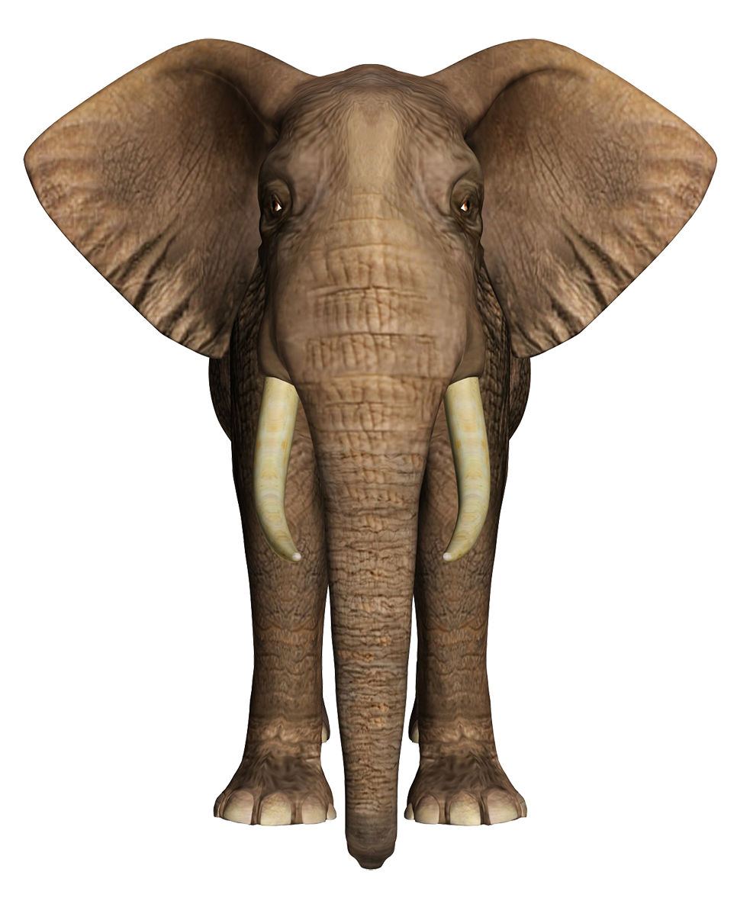

*I can* ***explain*** *how* ***energy*** *flows through an ecosystem (8.2)*

*I can* ***explain*** *how elephants serve as keystone species in their ecosystem (8.5)*

*I can* ***calculate*** *Simposon’s diversity Index to determine the* ***biodiversity*** *of a community (8.6)*

*I can i****nvestigat****e elephant poop and the elephants of Zimbabwe*

| Investigate: Elephant Poop  Your teacher won a grant and was gifted elephant poop from the African savanna and soil from there as well. Your teacher rocks!!  Make 2 observations on the elephant poop.  Compare and contrast the seed found in the elephant poop vs those found in soil.  Pose a question as to how elephants might impact the ecosystem. |
| --- |

*Use elephant slide 1 to fill in worksheet*

**Intro to elephants**

| Watch video <https://www.youtube.com/watch?v=Aw6GkiCvcWs>  What surprised you the most about elephants?  Pose a question about elephants. |
| --- |

**Energy flow through a community**

A **food web** shows feeding relationships among organisms

* Arrow means “gives its energy to”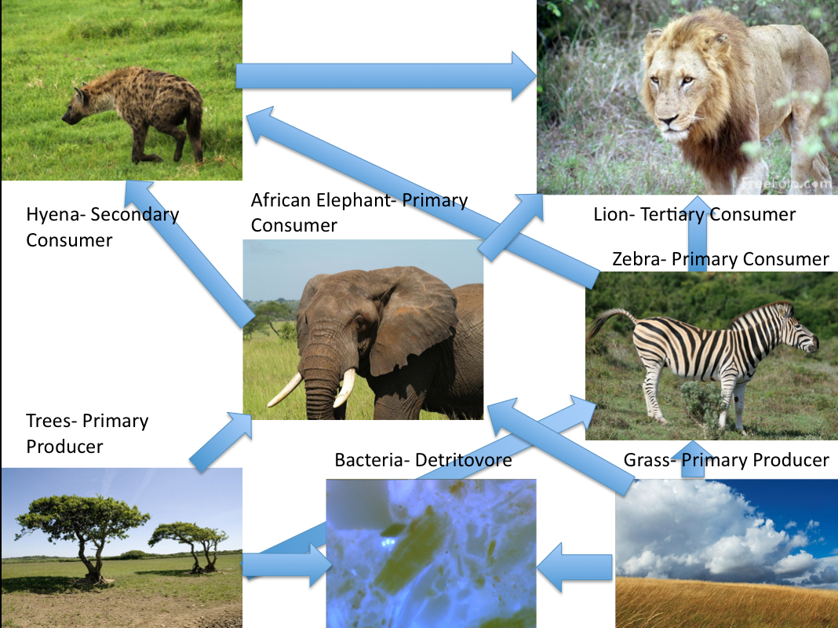

Describe the flow of energy starting at primary producer using “gives its energy to” each time



| What happens to energy as it moves through a food chain? **The 10 Percent Rule**  <https://www.youtube.com/watch?v=ScizkxMlEOM>  Notes:  **Explain** why there aren’t 20 trophic levels in a food chain |
| --- |

**Elephants as keystone species for biodiversity**

| Define **biodiversity**  Elephants are among the most intelligent of the creatures with whom we share the planet, with complex consciousnesses that are capable of strong emotions. Across Africa they have inspired respect from the people that share the landscape with them, giving them a strong cultural significance. As icons of the continent elephants are tourism magnets, attracting funding that helps protect wilderness areas. They are also **keystone species,** playing an important role in maintaining the biodiversity of the ecosystems in which they live.  During the dry season, elephants use their tusks to dig for water. This not only allows the elephants to survive in dry environments and when droughts strike, but also provides water for other animals that share harsh habitats.When forest elephants eat, they create gaps in the vegetation. These gaps allow new plants to grow and create pathways for other smaller animals to use. They are also one of the major ways in which trees disperse their seeds; some species rely entirely upon elephants for seed dispersal.  On the savannahs, elephants feeding on tree sprouts and shrubs help to keep the plains open and able to support the plains game that inhabit these ecosystems.  Wherever they live, elephants leave dung that is full of seeds from the many plants they eat. When this dung is deposited the seeds are sown and grow into new grasses, bushes and trees, boosting the health of the savannah ecosystem.  How are elephants **increasing the biodiversity** in their community    Watch <https://www.youtube.com/watch?v=hRGg5it5FMI> Some Animals Are More Equal than Others: Keystone Species and Trophic Cascades Notes  -  -  -  -  **Predict** 4 or more events that would happen if elephants were removed from an area |
| --- |

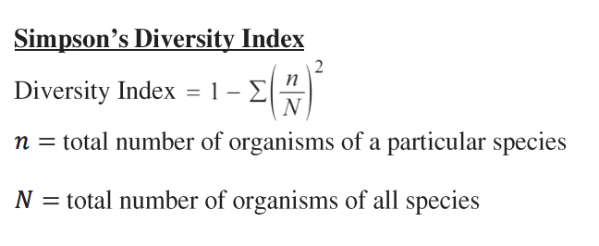

Ecosystems such as old-growth forests and rainforests tend to be quite complex in their biodiversity and are stable. However, not all ecosystems have the same level of biodiversity. Humans have altered many ecosystems to reduce their complexity and diversity by converting previously unused forests into cropland, for example. The conversion of forests into croplands reduces biodiversity by creating **monocultures** (all the same species), which presents several problems. Nature’s tendency to increase biodiversity through succession is something humans battle in an attempt to maintain these monocultures. This is often done with the use of pesticides and herbicides which kill off undesirable species, but that also tend to create other problems when these substances are used to make it easy to harvest a crop for human use.

The Simpson’s Diversity Index is used to determine how biodiverse an area is. The formula we will use looks like this:

The index has values from 0 to 1. A large index value indicates a higher degree of biodiversity and a stable ecosystem with many niches and little competition, while a lower value indicates a lower degree of biodiversity which may indicate an ecosystem with a few dominant species and a greater degree of competition.

Let’s practice Simpsons

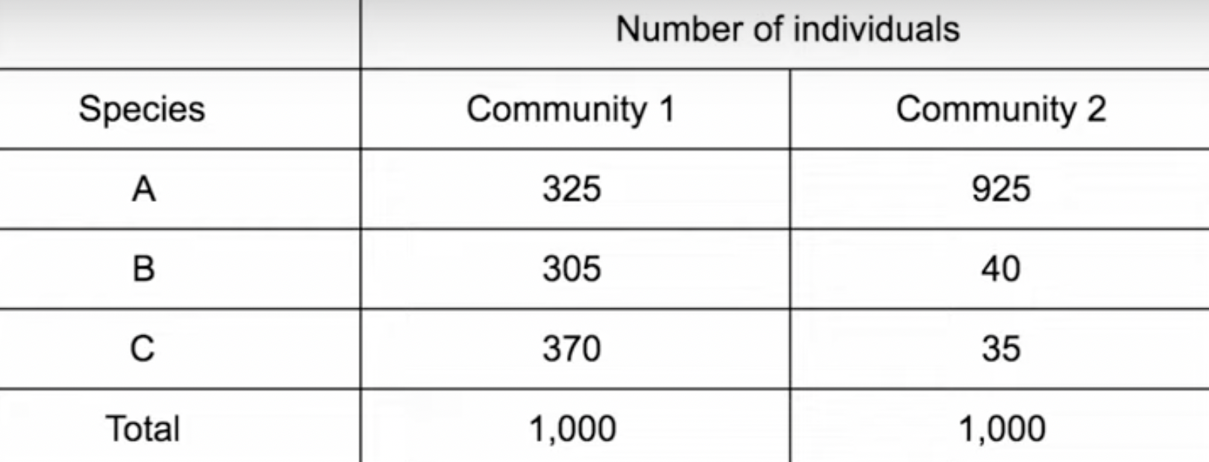

**Community 1--**

**1- [ (n/N)2 + (n/N)2 + (n/N)2]**

**1 – [ (325/1000)2 + (305/1000)2 + (370/1000)2]**

**1 – [ 0.106 + 0.0930 + 0.137]**

**1 – [0.336]**

**Answer: 0.664**

**What is the Simpson Diversity Index for Community 2?**

**Community 2--**

**1- [ (n/N)2 + (n/N)2 + (n/N)2]**

**-**

What conclusion can you draw about community 1 vs community 2?

| Community 1 | Community 2 |
| --- | --- |
|  |  |

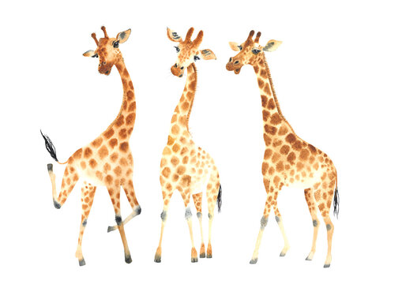

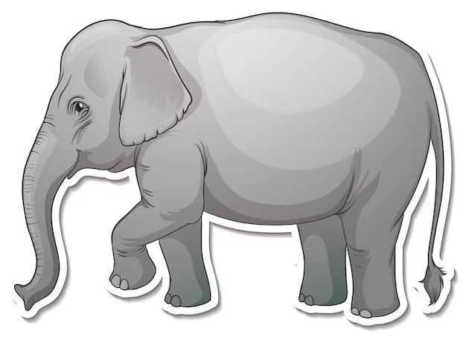=25% =25% 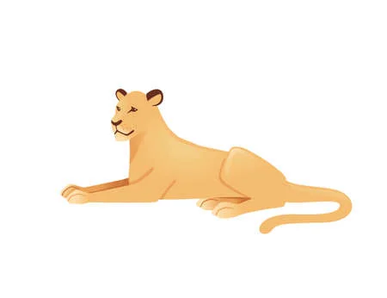=25% =25% =19% =19%  =50% 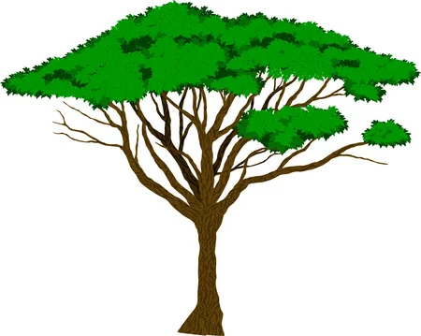=12%

Which community is the most diverse? Make a guess and circle community 1 or 2

Justify your guess

Simpsons Biodiversity Problem

*n* = the total number of organisms of a particular species

*N* = total number of organisms of all species

With this **index**, 1 represents infinite **diversity** and 0, no **diversity**

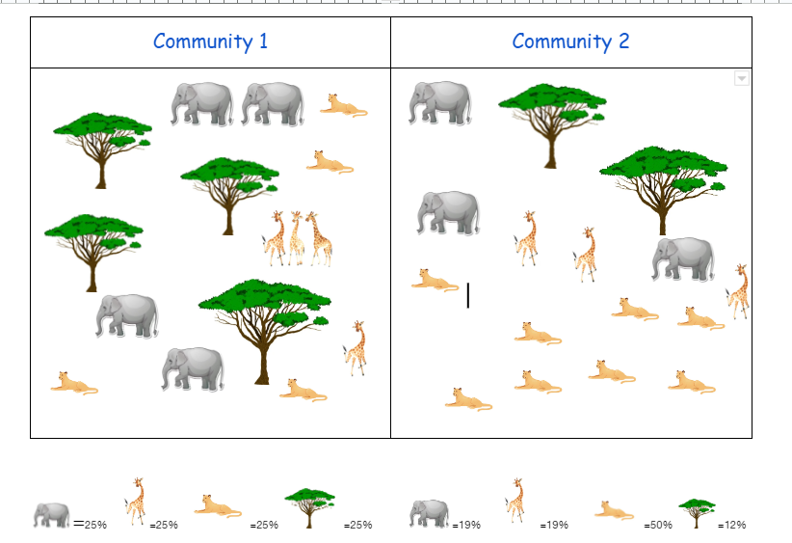

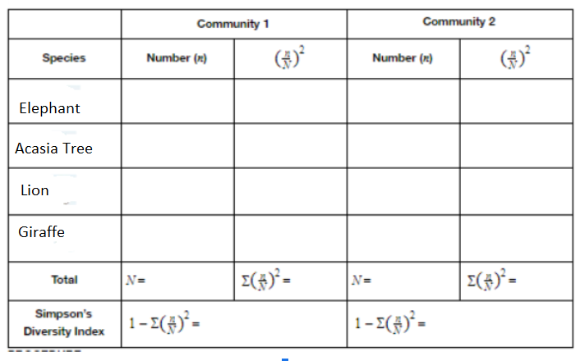

Which community has more biodiversity?

What is your evidence?

Elephants of Zimbabwe

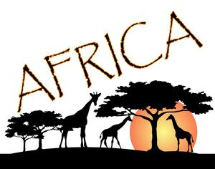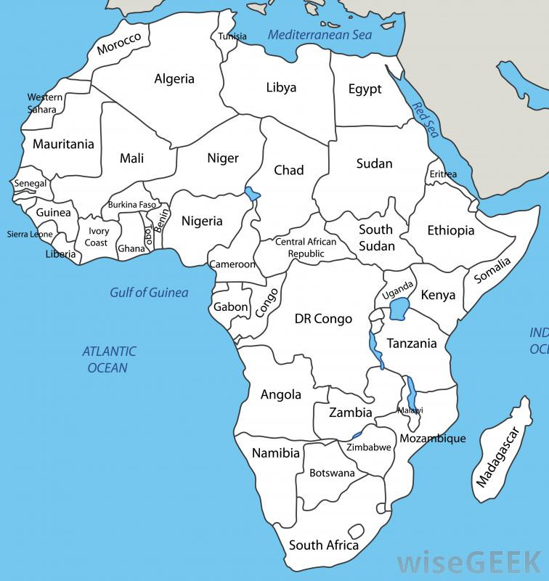



1. Color Zimbabwe on map
2. Scan, read, and describe

<https://qz.com/africa/2005322/zimbabwe-looks-to-elephant-hunting-for-revenue-lost-during-covid/>

| **Describe** the state of elephants of Zimbabwe |
| --- |